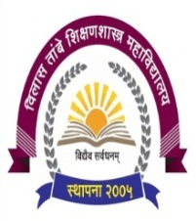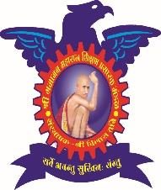

**Shri Gajanan Maharaj Shikshan Prasarak Mandal’s**

**Vilas Tambe women’s College of Education (B.ED.)**

**Dumbarwadi, Otur, Tal - Junnar, Dist - Pune - 412409**

All teachers of Vilas Tambe College of Education use various technologies while guiding various practicals. There are different sites from where teachers & students collects information, uses many more facilities of Internet, YouTube & Computer, etc.

1. <https://www.youtube.com/@DrVasudevVRaut/videos?view=0&sort=dd&shelf_id=0>
2. <https://classroom.google.com/?authuser=0>
3. <https://www.swayamprabha.gov.in/>
4. <https://shodhganga.inflibnet.ac.in/>
5. https://ess.inflibnet.ac.in/